Hale Carnival

SATURDAY 6th JULY 2024
Assembly from 4.45 pm - Judging at 5.15 pm – Procession at 6 pm
PROCESSION ENTRY FORM

Procession Organiser:
Larry Peppin, 12 Newmans Court, Folly Hill, Upper Hale, Farnham GU9 0SJ
Tel: 01252 723808 or 07527783588 E-mail: hale-carnival@hotmail.co.uk OR peppin677@gmail.com

I/We wish to take part in the Procession at the Hale Carnival on Saturday 6th July 2024

Name and Address of School/Club/Organisation/Group/Individual entering

……....................................................................................................................................................................

…….....................................................................................................................................................................

Contact Name: ………………………………………………………Contact Tel: ……………………………………………………………

Contact email address:………………………………………..Mobile Tel on the day:………..,………………………………

Class Entering (see attached sheet for details of the 5 Classes):……………………………………………………………..

Title of Entry:……………………………………………………………………………………………………………………………………….
(Class E entries please state: Make, model, year and colour of the vehicle you are entering)

Please indicate the Type of Entry i.e., pedestrian/float/classic car:……………….………………………………..

Please indicate the approximate number of people in your entry: ………………………………………………………..

Will your entry be playing music? …………………………………………………………………………………........................

Do any special requirements need to be considered?......................................................................

Please return this completed form to the Organiser, Larry Peppin, by post or by email as detailed above as soon as possible and to arrive no later than 24th May 2024. The Hale Carnival Committee look forward to seeing you all on the day!

HALE CARNIVAL - SATURDAY 6th JULY 2024

Route: Hale School Field/Upper Hale Road to Hale Recreation Ground

You must indicate on your application which of the classes you wish to enter and in each case the entry can be for a group or individual. There is no charge for entry and entries can be with or without a vehicle and can be with or without music. We would be grateful for as much information as possible on your application form so that we know where best to place your entry in the procession: -

CLASS

A Nursery and Infant Schools – up to age 7

B Junior and Senior Schools – ages 7 to 18

C Clubs/Organisations/Churches/Individuals/Groups – mainly children

D Clubs/Organisations/Churches/Individuals/Groups – adults

E Classic Vehicles - veteran/vintage/classic vehicles

Trophies will be presented to:
The winners in each class (and certificates for first, second and third);
For Best Overall Children’s Entry;
For Best Overall Adult Entry; and for
Most Original Entry
so, lots to aim for!
Note:
All entrants should start to gather on the Hale School Field from 4.45 pm onwards to be ready for judging which will start at 5.15pm. The procession moves off at 6pm sharp and will proceed down the hill and onto the green. It will do one lap of the green before dispersing. The route will be closed to other road users for the duration of the procession and will be adequately marshaled in liaison with the police to ensure the safety of those in the procession.

Facilities: It is a good idea to bring any required drinks/snacks with you if they are required during the wait for judging and before the procession moves off and adequate protection for the weather conditions. Toilet facilities are usually kindly made available in the Bungalow.

Street collection - to comply with the terms of the street collection license, collecting buckets will be handed out but all monies collected must be handed to the Hale Carnival Committee Treasurer in the Hale Carnival Committee Tent on the green.

Insurance - to comply with insurance requirements, please provide a copy of current valid motor insurance for all vehicles participating in the procession.

Data protection - by entering the procession, agreement is given for photographs to be taken and used in publicity/newspaper articles. Please note by submitting your details you are opting in for the Hale Carnival Committee to have your communication details on file.

Please return your completed entry form to:
Larry Peppin, 12 Newmans Court, Folly Hill, Upper Hale, Farnham GU9 0SJ
or email it to hale-carnival@hotmail.co.uk or peppin677@gmail.com
Thank you and we hope you will join in the fun.

Map of procession route. (Image of map taken from Google Maps)

Meet at Hale School Grounds HERE

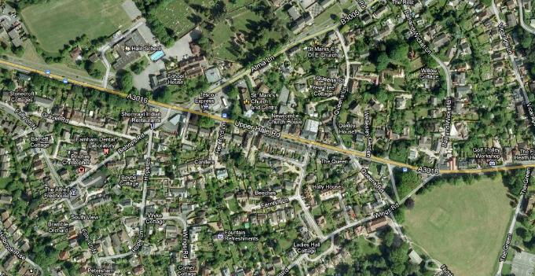
Procession ends HERE on the Green

